**Index of Connectedness**

Index of connectedness is a project which shows the connectedness of young people in a community.

From technical point of view,

This project shows the graphical representation of the connectedness of a particular community in which user is interested.This information helps the user to understand in what kind of community/region is his/her child being raised.

1.This is a web-base application.

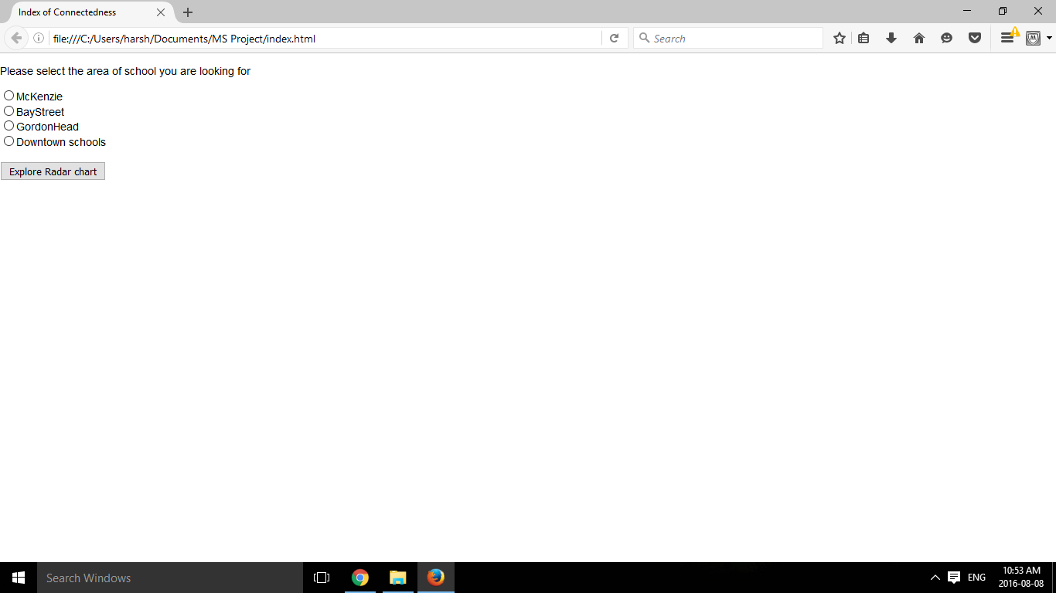

**2.**Now user will select one school for which he wants to the check the connectedness of youth based on different factors**.**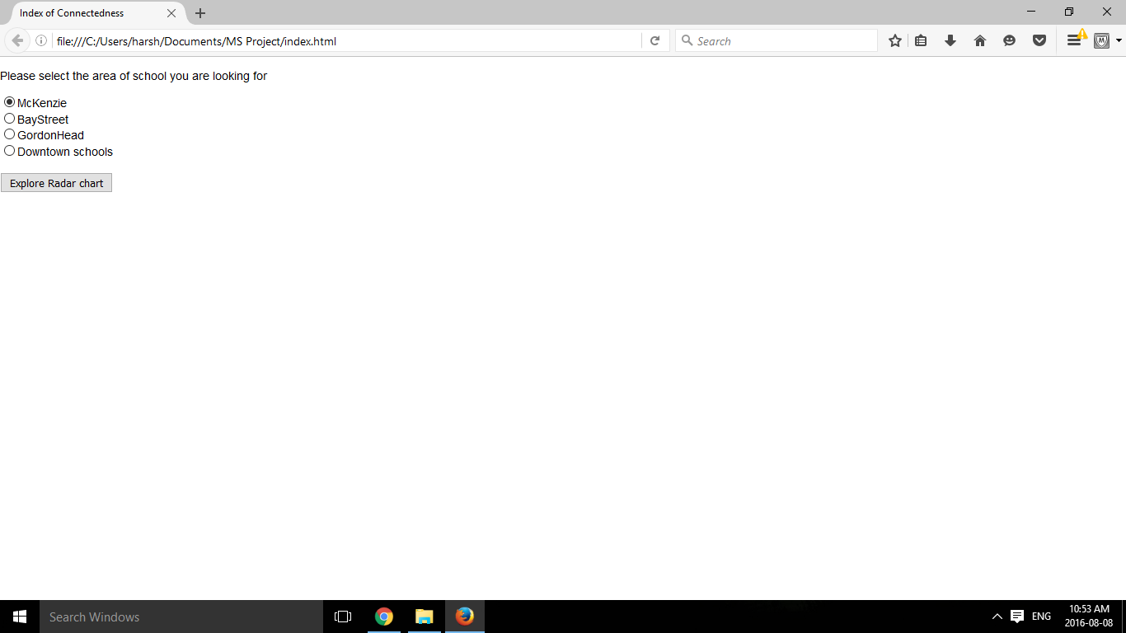

**3.**When user clicks on the Explore Radar chart button, radar chart for this particular school is selected from a csv file and is generated as shown below:

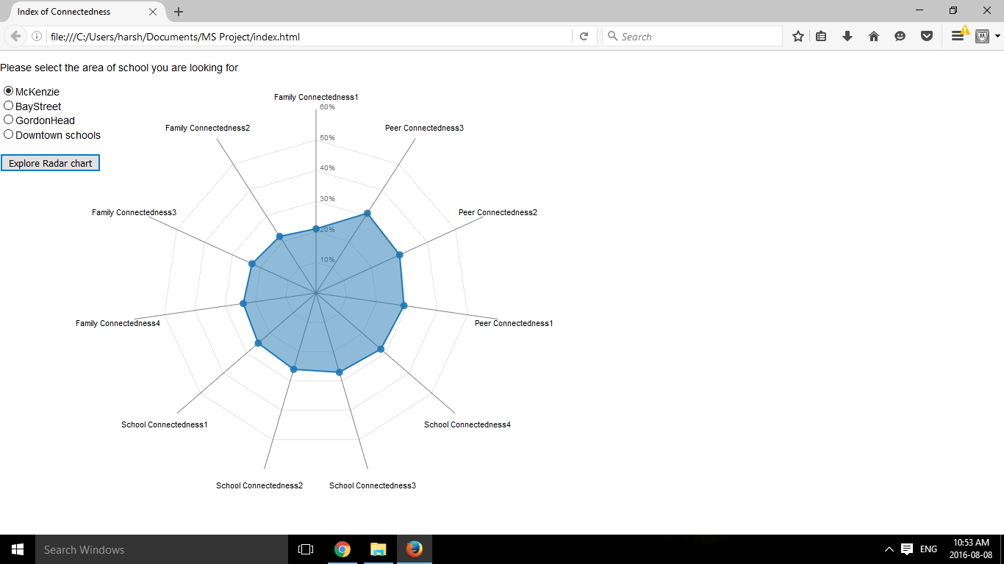

**4.**Now user clicks on other school name say “Bay street school”

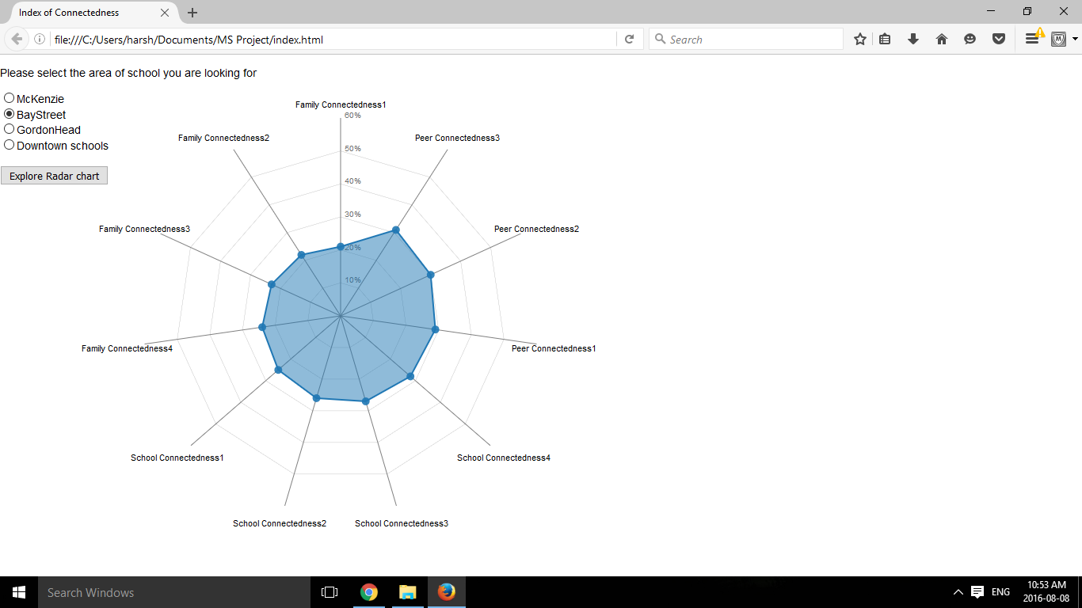

**5.**Then the graphical data related to Bay street school is represented.

